EXP 14
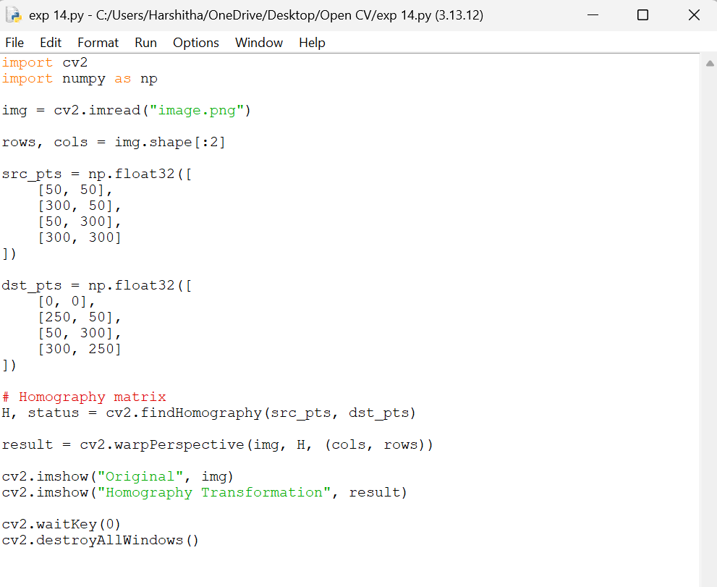
Aim:
To perform image transformation using a Homography Matrix in OpenCV with Python by mapping corresponding points between two planes to achieve perspective correction and geometric transformation of the image.

